GUIDELINES

(By Subrata Sir & group of ICSE and CBSE school teachers)

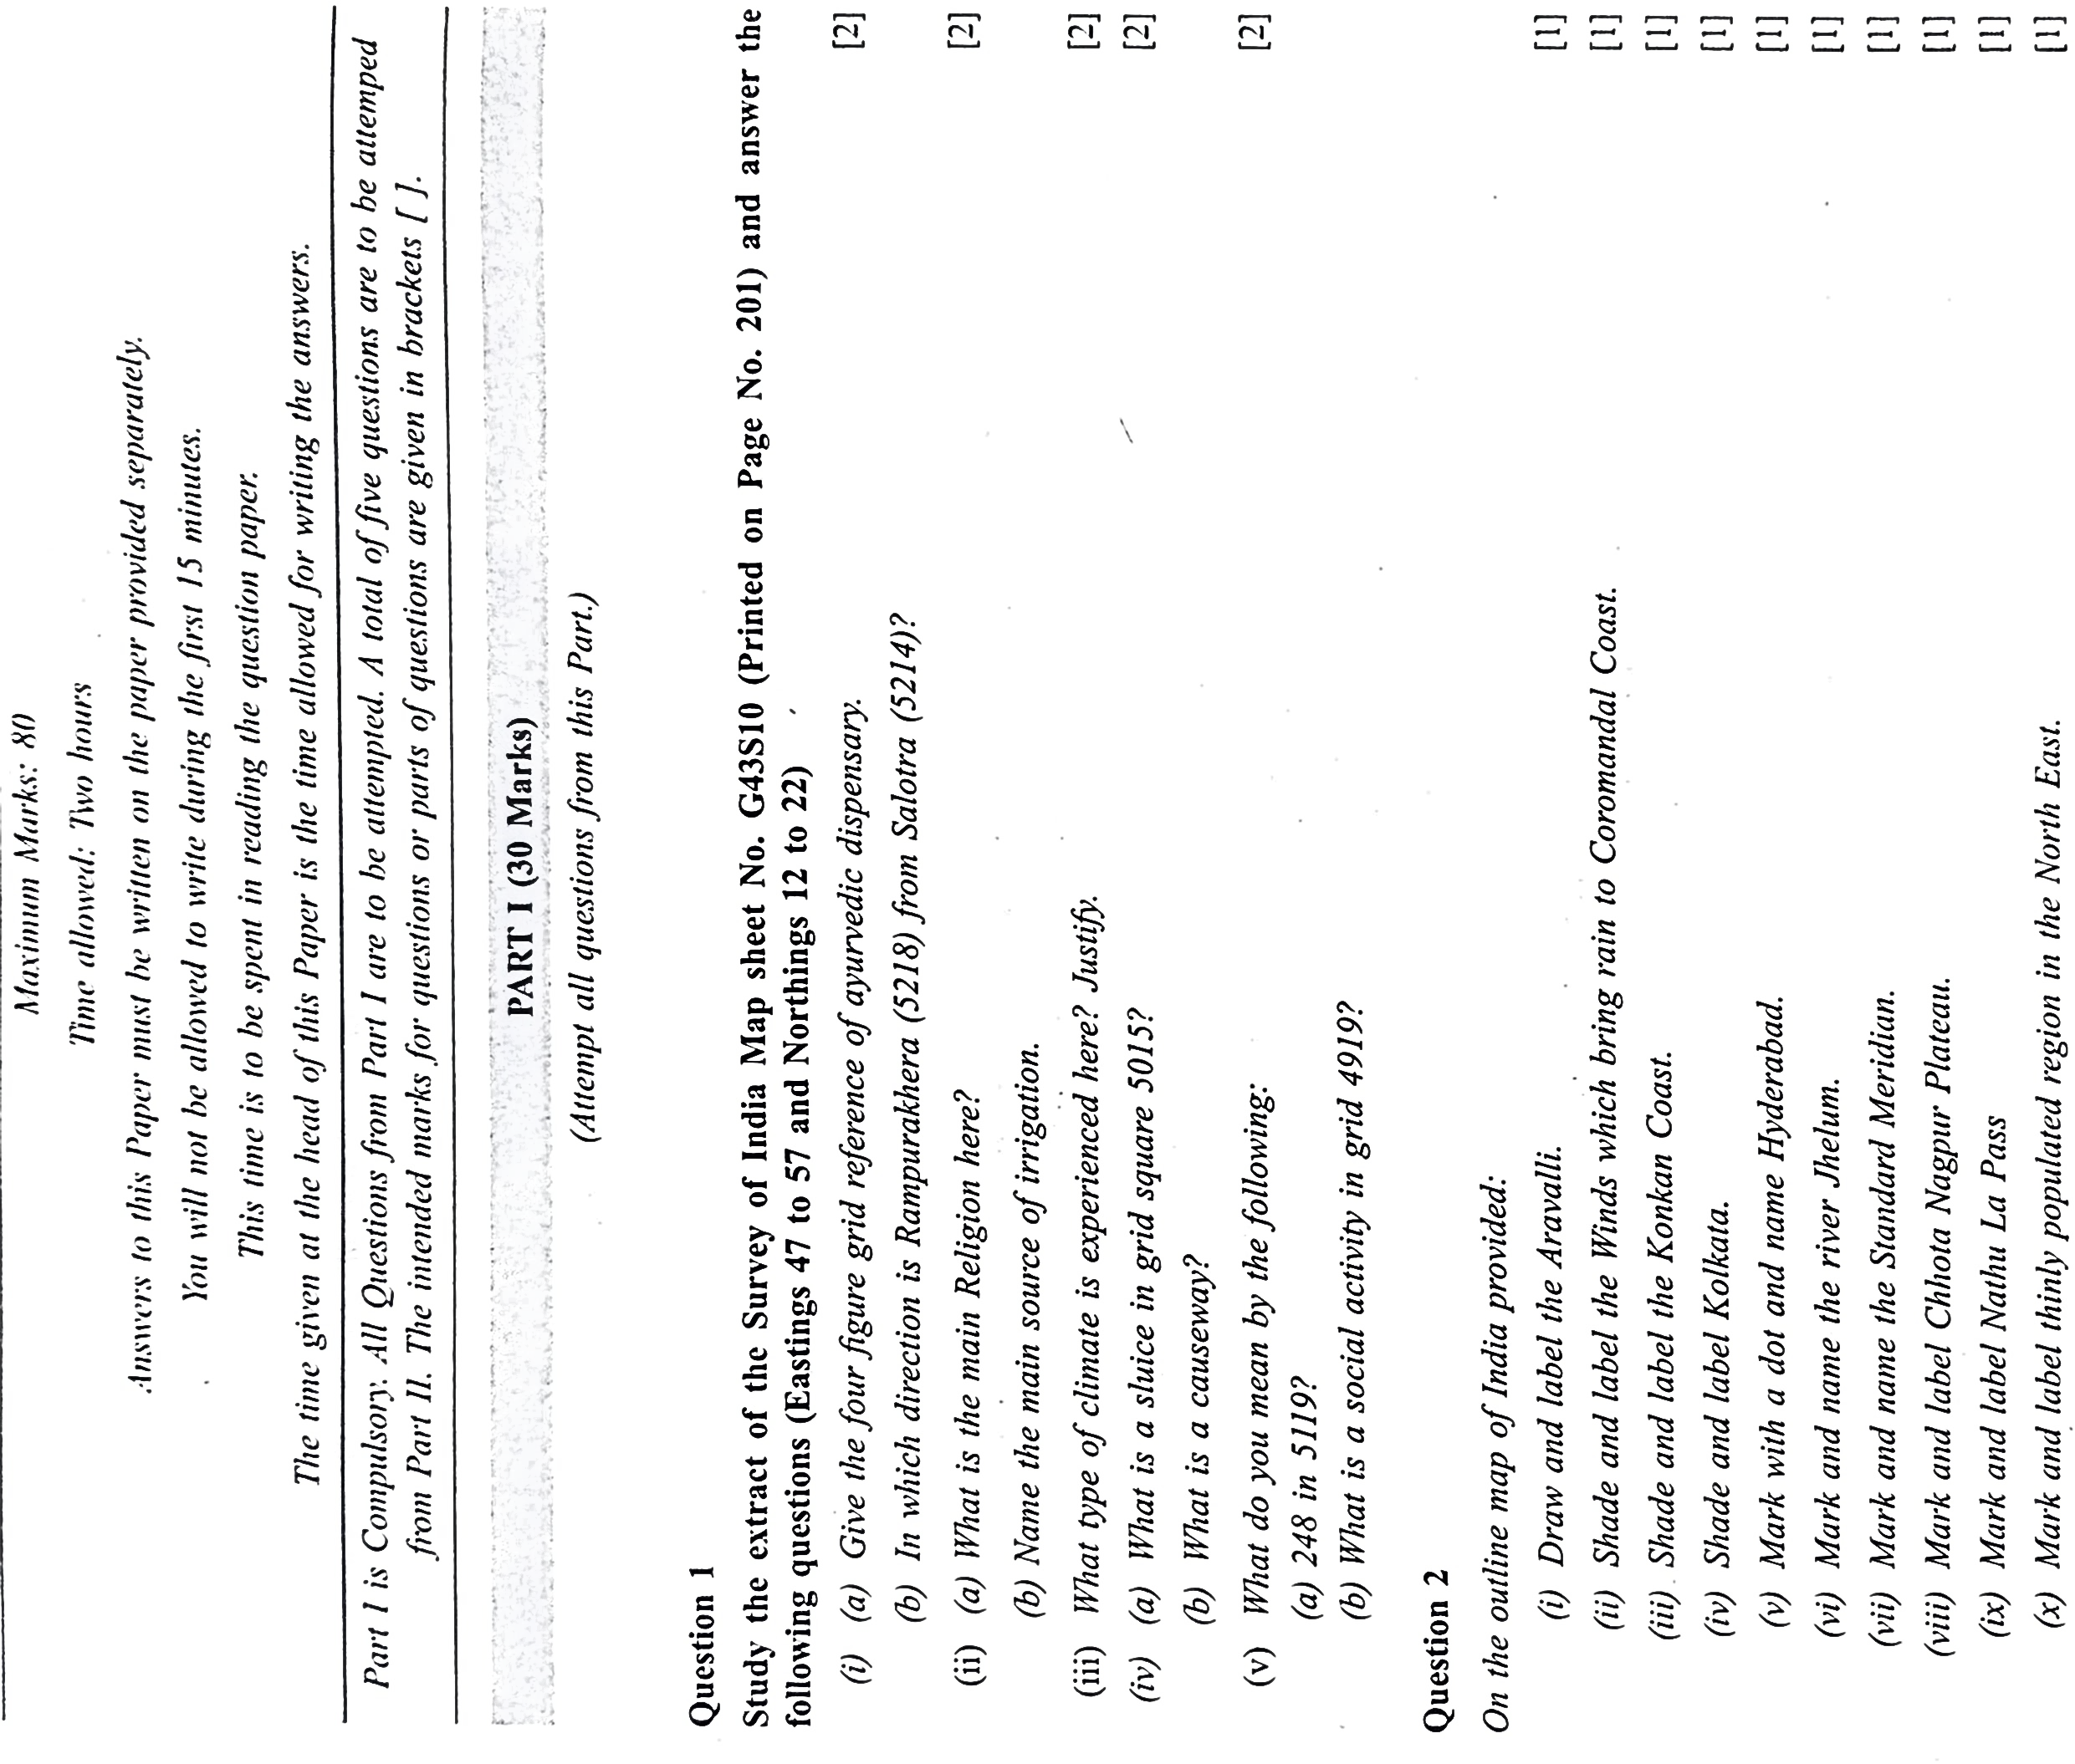

**PART I (30 Marks)**

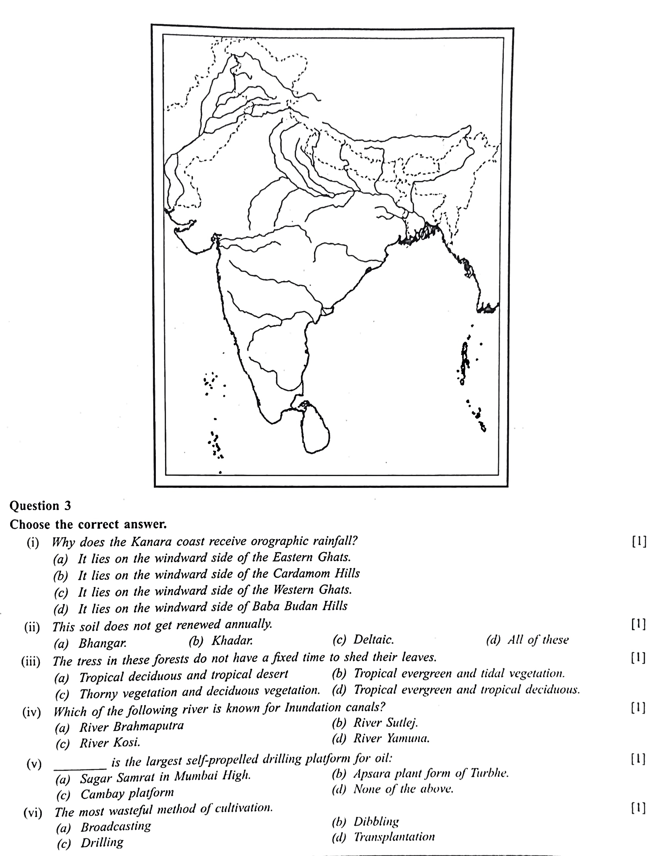

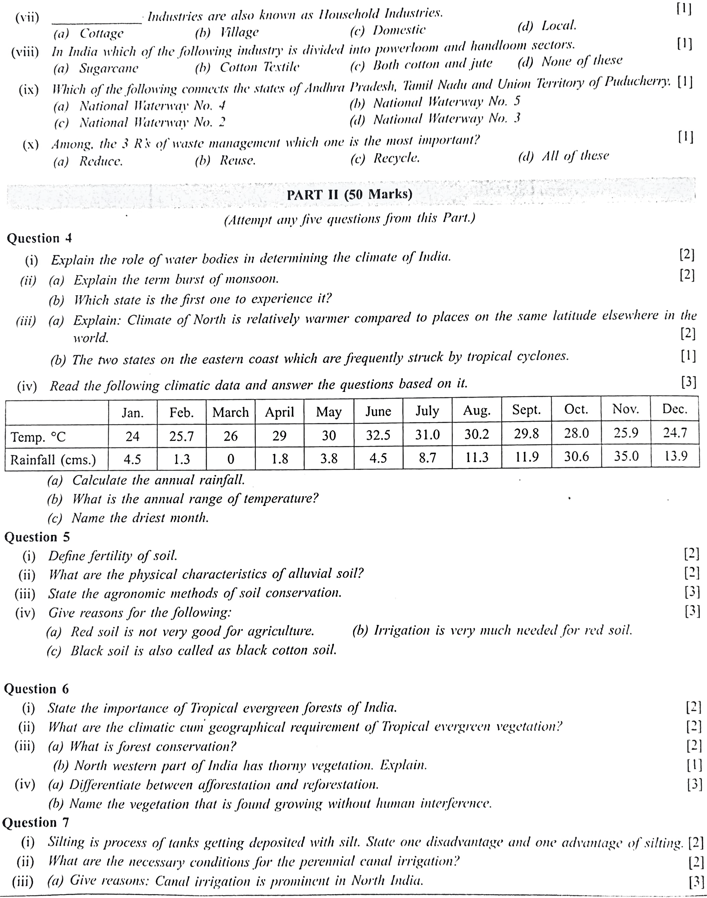

**PART II (50 Marks)**

